The Earswitch: Prototypes

Hardware:

1) Original set-up

“Teslong Mini Otoscope, USB Ear Otoscope Inspection Camera with 6 LED Light”
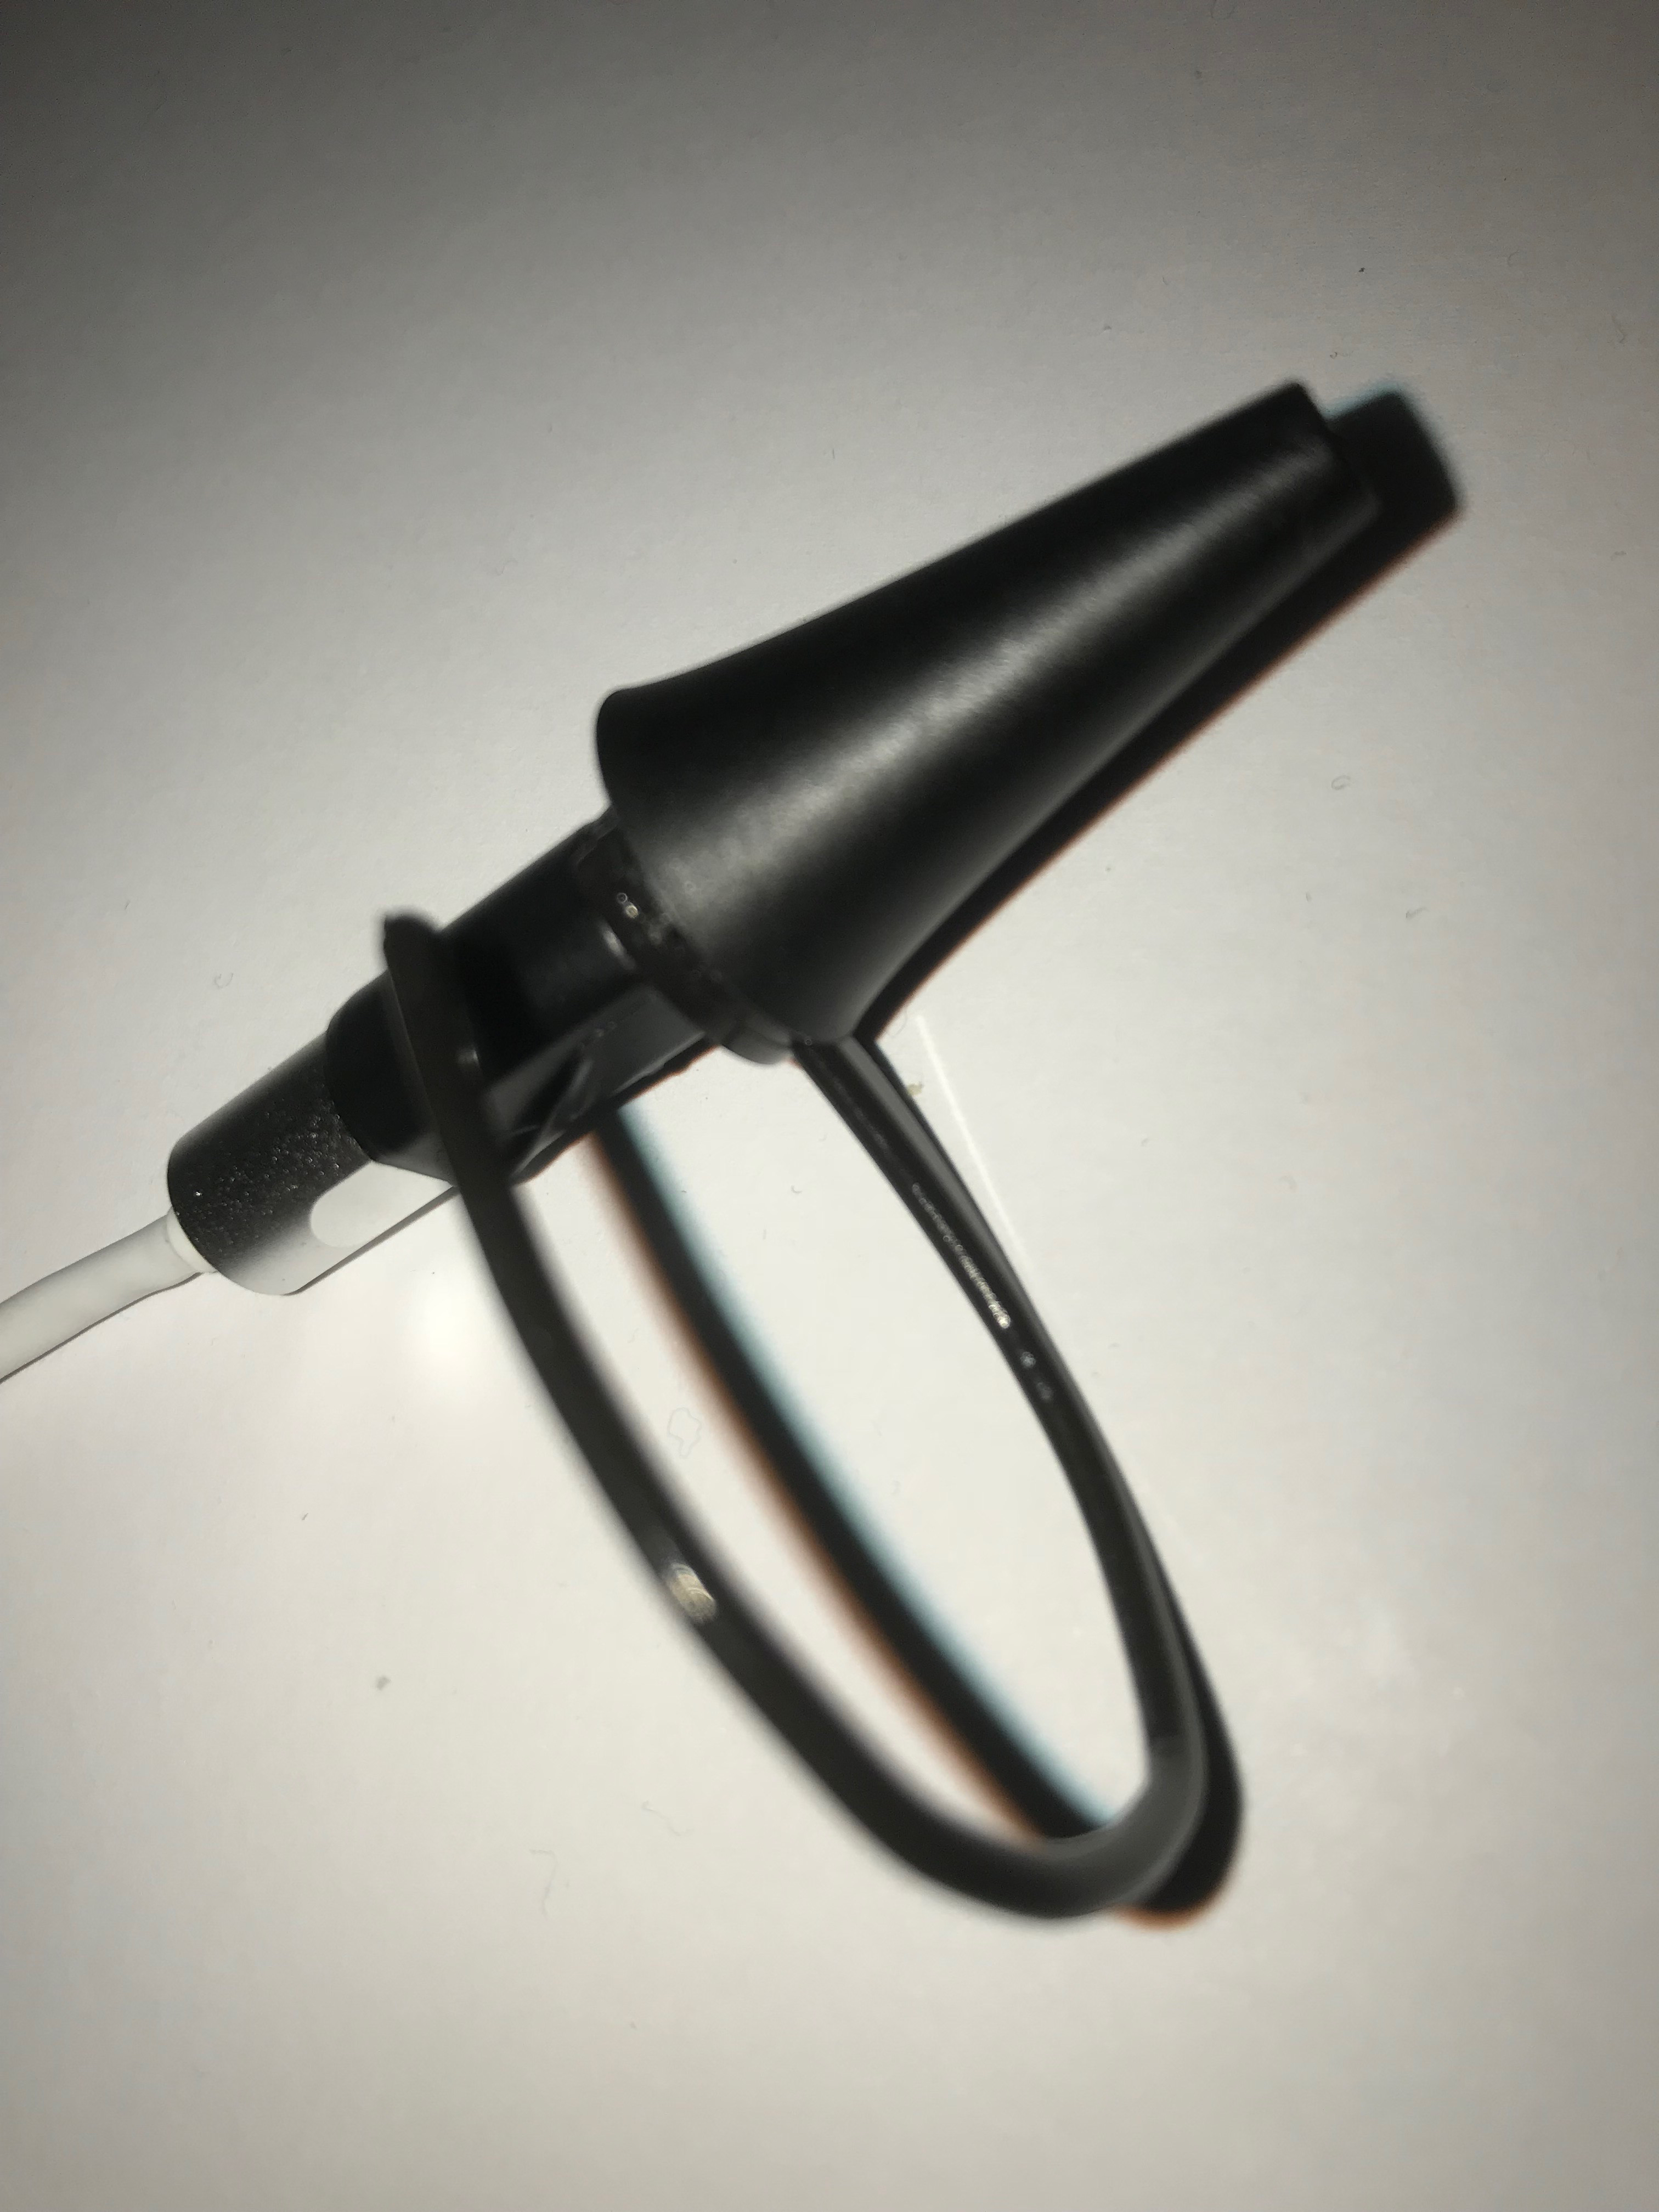
Anchored by ear-hook for blue-tooth headset
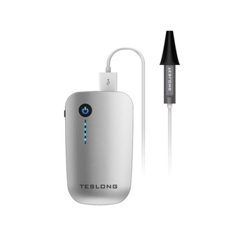

This Teslong Mini Otoscope size is no longer available on Amazon but currently showing on Alibaba with a USB connector into a WiFi unit:
https://teslong.en.alibaba.com/product/60834161549-800420007/TESLONG_Medical_Device_Personal_Care_Professional_1_8M_Cable_6_2MM_1280_720_WiFi_HD_Video_Camera_Otoscope.html?spm=a2700.icbuShop.41413.28.c20644a6sEtdRX

Advantage over current newer models available on Amazon is that this is shorter and easier to anchor with ear-hooks:
Replacement Spare Earhook Ear Hook Loop Earloop Clip For Bluetooth Headset
https://www.ebay.co.uk/itm/191624222415

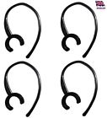
However current newer models are suitable for showing the ear-drum movement but as they are a lot longer they would be harder to anchor when being used as The Earswitch, although probably more easy to manipulate to get views of the drum for general videos:

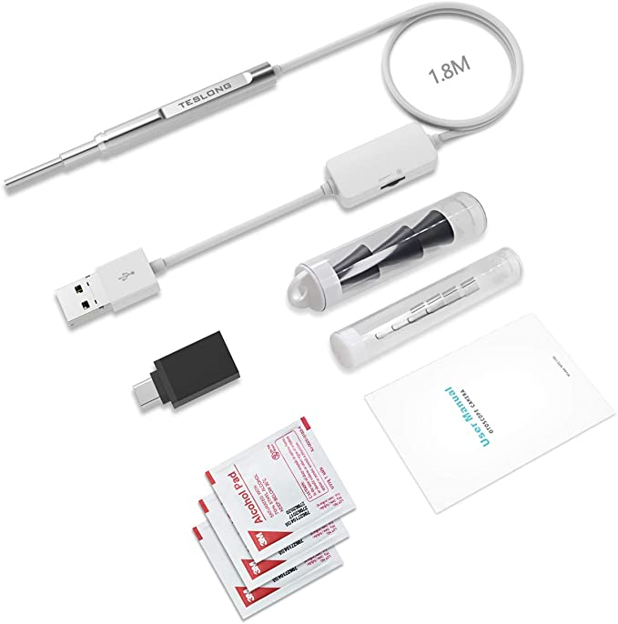
Teslong USB Otoscope, 4.3mm USB Ear Otoscope Inspection Camera with 6 LED Lights for Samsung LG Sony Android Mac and PC: https://www.amazon.co.uk/gp/product/B07R464QMJ/ref=ppx_yo_dt_b_asin_title_o00_s00?ie=UTF8&psc=1

2) Second smaller ear-piece prototype; v2
smaller 4mm diameter otoscope : based on Omnivision OV7695 sensor embedded in Decibullz moulded earplug
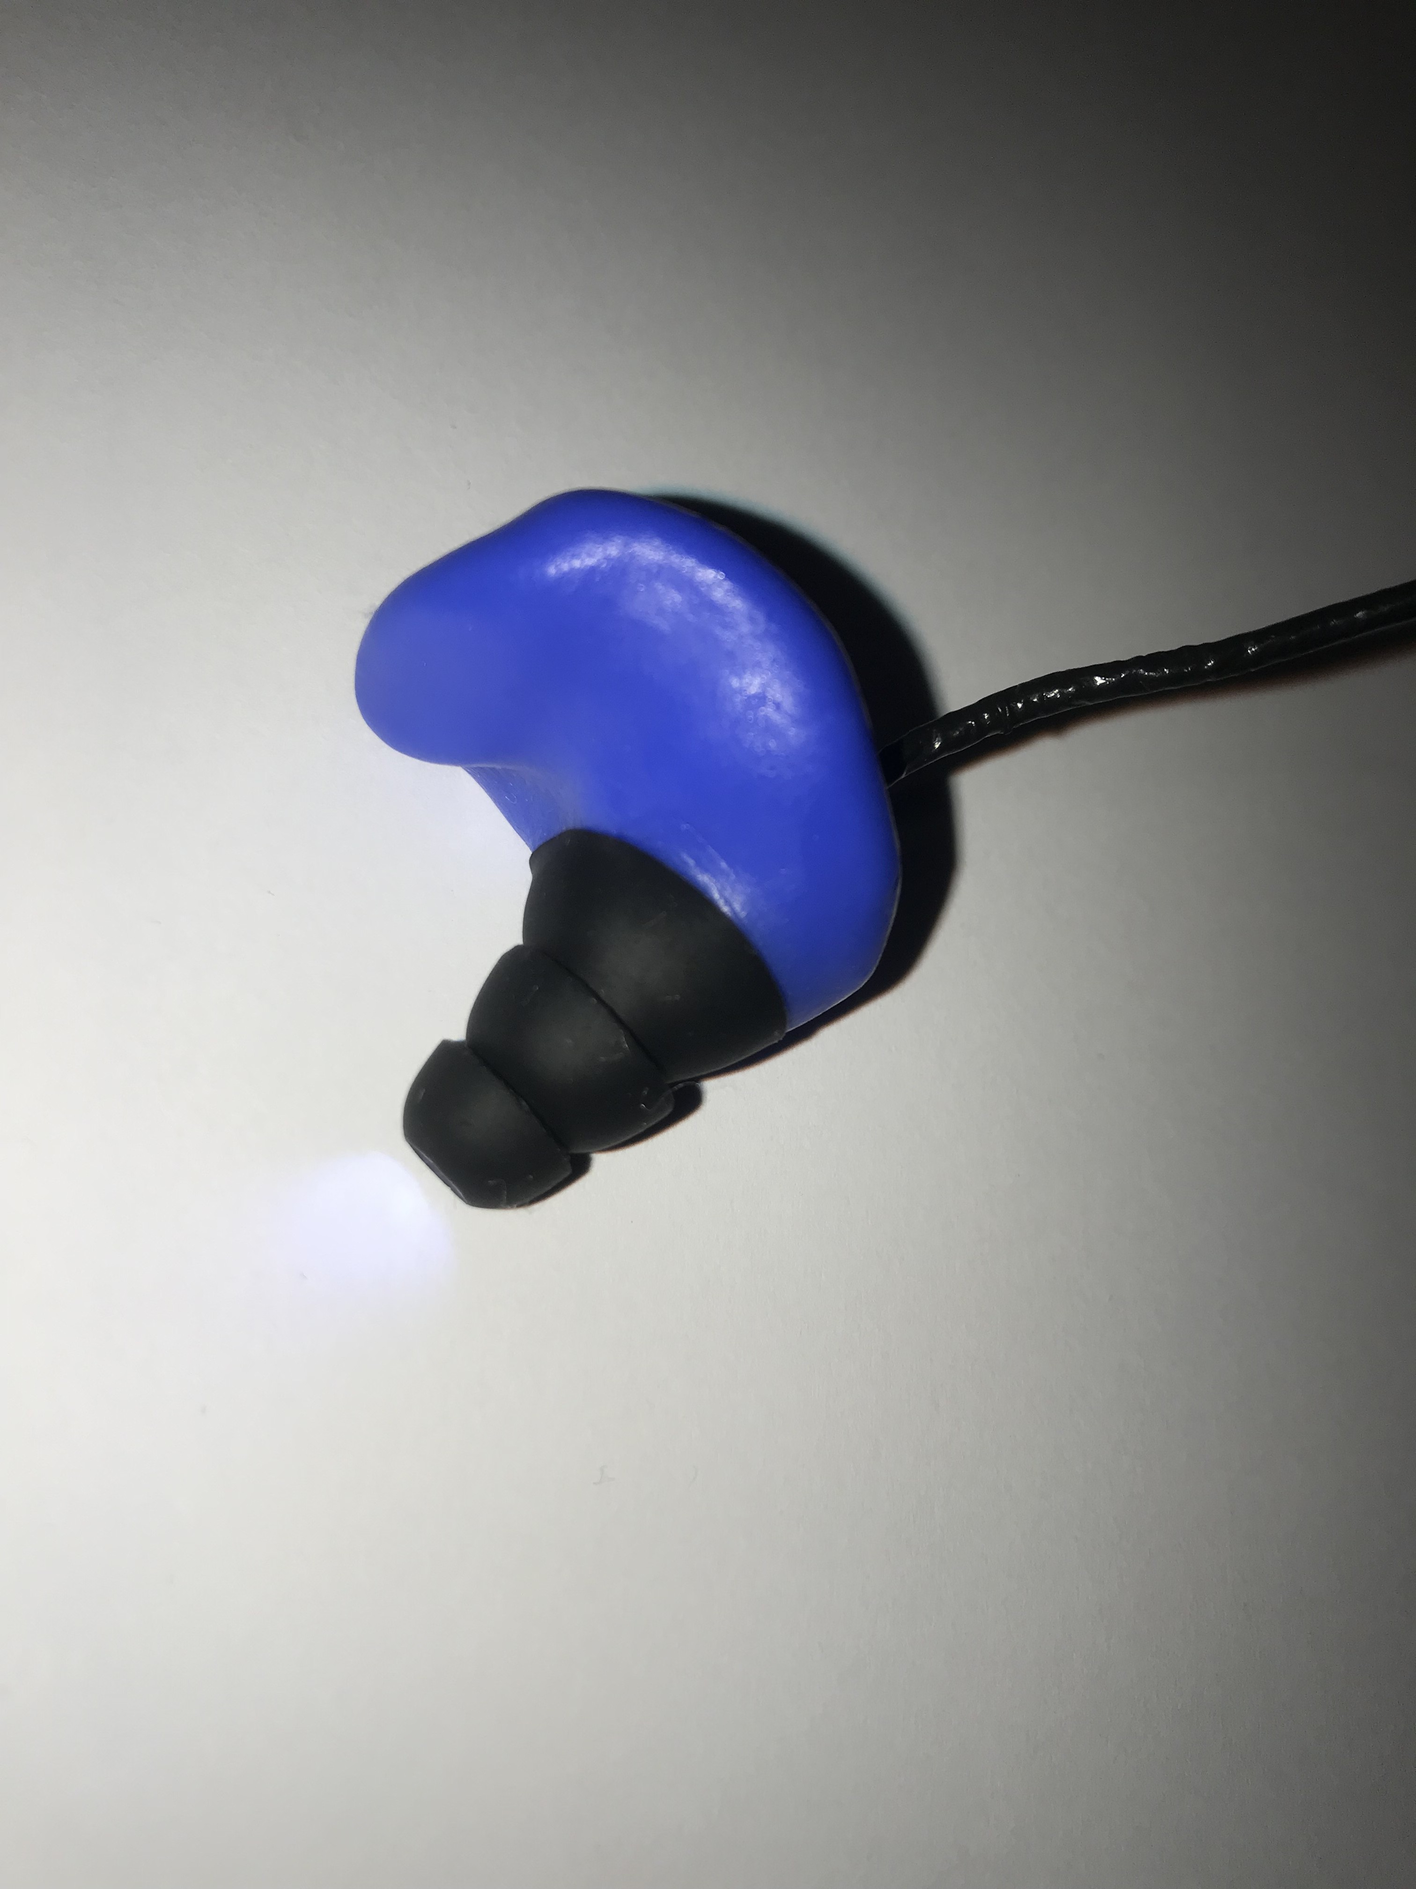
Otoscope obtained from Ralcam, though no longer available on their website :
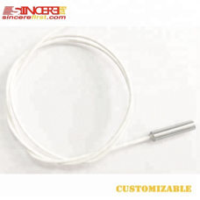
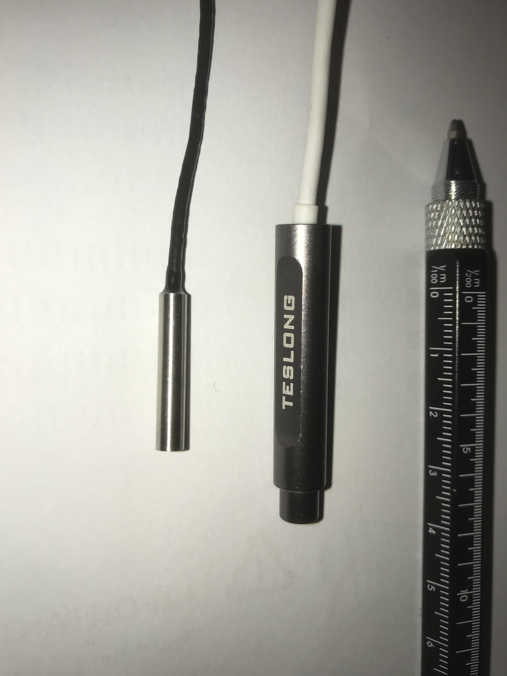

https://www.alibaba.com/product-detail/Tiny-Camera-1-13-inch-CMOS_62145993737.html?spm=a2700.galleryofferlist.0.0.711f1a26x8QbaA
Comparison of the 2 otoscopes Decibullz moulded earplugs (Amazon)

Alternative miniature otoscopes on Alibaba that may work:

OV6922 image sensor 0.1MP 3.0mm 3.5mm 3.9mm 4mm mini USB medical endoscope camera module (https://www.alibaba.com/product-detail/OV6922-image-sensor-0-1MP-3_60792817039.html?spm=a2700.galleryofferlist.normal_offer.d_title.7df735a8ur4NIo)

Future Prototypes:

The configuration may be better with the CMOS camera at the end of a narrow device, with the camera located at an angle ( with only one LED to reduce power/ temperature and increase contrast) to navigate the tortuous ear-canal (see diagram below from: https://www.hearingreview.com/practice-building/practice-management/earmold-retention-issues-why-does-this-earmold-keep-falling-out ).

Software:

Download the following programme it allows the ear-drum movement to control the keyboard:

﻿https://sourceforge.net/projects/sviacam/

Open Microsoft “On-Screen Keyboard” ( present on Windows PCs)
can Search for it on the search bar next to Windows icon bottom left
Select-> Options
->Scan through keys: Speed 1.5 secs
-> Use keyboard key; F12
-> Use Text Prediction
->Insert Space after predicted words

Open SwitchViaCam as Administrator (Right Click and click on “Run as Administrator”)- this allows SwitchViaCam to run as a background Window. If you can’t run as Administrator then just double-click to open; will need SwitchViaCam window to be running in the foreground

See the screenshot below:
Plug in the USB Otoscope
Click (top line)
Configuration> Selected Camera-> USB Otoscope Camera (needs to be plugged in)

If SwitchViaCam crashes then unplug otoscope
May need to adjust; Camera Properties for the PC webcam to: e.g.
Format 640x480
Capture Speed 5
& then plug in the USB Otoscope and restart SwitchViaCam & select the Otoscope under the Configuration Menu

Sensor 1 (blue)
Select: Advanced
Alter:
Motion Detection Threshold -> try 0.044 (drag slider)
(May need to be altered to get required sensitivity)
Put Otoscope into ear:
Sensor 1-> Enable Sensor - select box
Drag and expand selection box (blue box) to cover most of the middle of the eardrum image (will be shown in the black box shown here)
Change “Event type” ->F12
Alter
Time Filter -> try 488ms (drag slider)

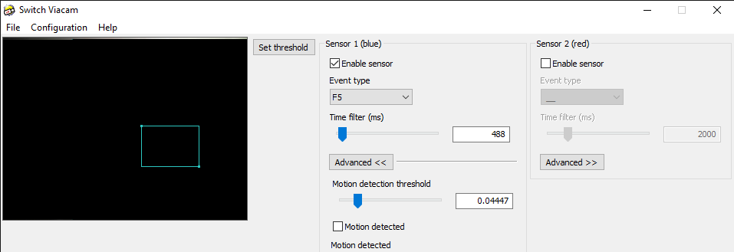

Open: Word (Reduce the size of the Word Window: not minimise- so you can still see the image of your ear-drum)

Then when you move the eardrum it should start scanning sequential rows on the keyboard
Once on the correct row “Earclick” to select & it scans across the row
“Earclick” the group of letters to select
“Earclick” once the letter of interested is highlighted

NG
25.10.20

